Cyber Security and Artificial Intelligence for cloud based Internet of Transportation Systems

Dr. R. Tamilkodi S. Ratalu N. Nani
Computer Science & Engineering Computer Science & Engineering Computer Science & Engineering Godavari Institute of Engineering and Godavari Institute of Engineering and Godavari Institute of Engineering and
Technology (A) Technology (A) Technology (A)
Rajahmundry, India Rajahmundry, India Rajahmundry, India tamil@giet.ac.in ratalu@giet.ac.in neelapunani2580@gmail.com

V. Sowmya P. Lohith Kumar K. Vamsi
Computer Science & Engineering Computer Science & Engineering Computer Science & Engineering Godavari Institute of Engineering and Godavari Institute of Engineering and Godavari Institute of Engineering and
Technology (A) Technology (A) Technology (A) Rajahmundry, India Rajahmundry, India Rajahmundry, India
swmya2384@gmail.com lohithkumar0003@gmail.com vamsikoribilli@gmail.com

Abstract—The Internet of Things (IoT) has major implications in the transportation industry. Autonomous Vehicles (AVs) aim at improving day-to-day activities such as delivering packages, improving traffic, and the transportations of goods. AVs are not limited to ground vehicles but also include aerial and sea vehicles with a wide range of applications. The IoT systems consisting of a collection of AVs have come to be known as the Internet of Transportation systems. While such IoT systems manage large quantities of sensor data, much of the data is also sent to a cloud for offline analysis. While there is great potential in AVs and the improvements it can make to the transportation industry, security and privacy concerns pose new challenges that need to be addressed as we move forward. In addition, Artificial Intelligence techniques are also becoming crucial for such IoT systems to be able to intelligently manage the AVs. This paper discusses AI and security for cloud-based Internet of Transportation Systems
Keywords – ‘Cyber Security, Artificial Intelligence, AI, Cloud Internet of Transportation’.
- INTRODUCTION
In the rapidly advancing landscape of technology, the integration of artificial intelligence (AI) and cyber security has become imperative, especially within the cloud-based Internet of Transportation Systems (IoTs). As transportation systems become more interconnected and reliant on cloud infrastructure, the need to fortify these networks against cyber threats become paramount [1]. The introduction explores the intersection of AI and cyber security in the context of cloud-based IoTs, highlighting the significance of safeguarding transportation systems in an era of digital transformation. Innovations like smart vehicles and autonomous vehicles AV’s introduce complexities that heighten vulnerability to attacks, potentially disrupting services and compromising safety [2].
This paper explores how Artificial Intelligence, Security and the Cloud can be integrated to develop Intelligent Internet of Transportation Systems. We first discuss the integration of cyber security. Next, we discuss how a secure cloud may be utilized to carried out data analytics for the Transportation Systems. We discusses security and privacy for the data Transportation Systems. We discusses how the various components (e.g., AI, Security for Cloud) can be integrated to provide Intelligent and Secure Transportation System. Autonomous Vehicles (AVs), including aerial, sea, and ground vehicles, assess their environment with a variety of sensors and actuators that allow them to perform specific tasks such as navigating a route, hovering, or avoiding collisions [3]. So far, AVs tend to trust the information provided by their sensors to make navigation decisions without data validation or verification, and therefore, attackers can exploit these limitations by feeding erroneous sensor data with the intention of disrupting or taking control of the system. The Internet of Transportation Systems are subject to attacks (like any cyber physical system). Streaming data is being collected from such systems including autonomous and in the future driverless vehicles. As transportation systems go electric, they need energy conservation. Threats to the security of such systems could cause massive damage including accidents, loss of lives as well as being stranded on lonely highways due to attacks on energy management [4].
- LITERATURE SURVEY
The advent of Smart Industry 4.0 has brought about significant advances in automation, efficiency, and productivity in industrial environments. However, these technological advances also pose new challenges for cyber security. The increasing interconnectivity of devices and systems within Smart Industry 4.0 environments makes them vulnerable to cyber attacks and security breaches. To address these challenges, there is a need to integrate AI with cyber security in Smart Industry 4.0 applications. AI can be used to analyze large amounts of data from sensors and devices within the industrial environment to detect and prevent cyber threats [5]. Machine learning algorithms can be trained to identify patterns of normal behavior and flag any deviations as potential security threats. There are different AI-based cyber security techniques that can be used, such as anomaly detection, intrusion detection, malware detection and predictive analytics [6]. These techniques can be used in conjunction with other cyber security measures, such as firewalls, intrusion detection systems, and security information and event management (SIEM) tools, to provide a comprehensive approach to cyber security for Smart Industry 4.0 applications. Integrating AI with cyber security for Smart Industry 4.0 applications can help improve the security posture of industrial environments and reduce the risk of cyber attacks and data breaches. However, it is important to ensure that these technologies are properly implemented and configured to avoid unintended consequences and potential vulnerabilities. By carefully designing and implementing AI-based cybersecurity solutions, organizations can protect their industrial environments from cyber threats and ensure the reliability and safety of their operations [7].
This paper first describes the security and privacy challenges for the Internet of Things IoT) systems and then discusses some of the solutions that have been proposed. It also describes aspects of Trustworthy Machine Learning (TML) and then discusses how TML may be applied to handle some of the security and privacy challenges for IoT systems [8].

This study examines how blockchain technology and consensus mechanisms can safeguard and grow the metaverse ecosystem. Blockchain is transparent and decentralized. It is unchangeable, cryptographically verified, and runs without a central authority. Blockchain technology can secure the metaverse and users' data. This study compares blockchain-based consensus algorithms such as POW(PoW), PoS, and PBFT to ensure metaverse safety [9]. These consensus mechanisms provide safe, decentralized transaction verification, waste reduction, and network consensus. Studying blockchain technology's metaverse scaling restrictions and scaling solutions, including sharding, sidechains, and off-chain protocols. These methods increase throughput, parallel computing, and transaction speed. They improve the metaverse's eco-system. Quantitative analysis, simulations, and experiments determine the security and scalability of blockchain-based metaverse consensus processes [10]. Changes will be quantified by measuring transaction speed, network throughput, and resource consumption. This study enables safe, scalable metaverse environments. Block chain-based consensus mechanisms allow the metaverse to retain user data safely, halt undesirable conduct, and allow users to join without trusting each other. Scalability solutions declutter networks, enabling the metaverse to handle more individuals and transactions. Blockchain-based consensus mechanisms could make the metaverse more secure, private, and scalable [11]. Users will trust each other, create new apps, and be more open to this groundbreaking digital world.

Massive amounts of data are being collected, stored, and analyzed for various business and marketing purposes. While such data analysis is critical for many applications, it could also violate the privacy of individuals. This paper describes the issues involved in designing a privacy aware data management framework for collecting, storing, and analyzing the data [12]. We also discuss behavioral aspects of data sharing as well as aspects of a formal framework based on rewriting rules that encompasses the privacy aware data management framework [13].
Technological advancements such as the Internet of Things, mobile technology, and cloud computing are embraced by organizations, individuals, and society. The world is becoming more reliant on open networks, which fosters global communication and cloud technologies like Amazon Web Services to store sensitive data and personal information [14]. This changes the danger landscape and opens new opportunities. As the number of people who use the Internet grows, so does the number of cyber risks and data security challenges that hackers pose. A cybersecurity threat is an action that aims to destroy or damage data, steal data, or otherwise disrupt digital life. Computer viruses, data breaches, and Denial of Service (DoS) [15] assaults are all examples of cyber dangers. We'd be witnessing a notion of scanning enormous volumes of data across the internet if we described how AI systems might discover where hacks came from and recommend solutions to decision-makers within the corporation. Keywords Artificial intelligence Machine learning UEBA Cybersecurity threats Vulnerability Machine learning Security [16].
Integrating AI-based cybersecurity solutions for Industry
4.0 or IoT systems requires sophisticated design and configuration. Misconfigurations or improper implementations may lead to unintended vulnerabilities, reducing overall effectiveness. While privacy-aware data management frameworks offer solutions to mitigate privacy violations [17], they struggle with balancing data sharing and privacy, especially in the context of massive data collection in IoT or quantified-self applications. Behavioral aspects of data sharing introduce further complexities in ensuring complete privacy compliance [18]. Trustworthy Machine Learning (TML) for securing IoT and other systems may struggle with ensuring model accuracy and trust in highly dynamic environments. False positives in detection systems can cause unnecessary alarms, while false negatives leave systems vulnerable to undetected threats [19].
In the context of the rapidly evolving landscape of transportation systems that leverage cloud computing and the Internet of Things (IoT), our work positions itself at the intersection of cyber security and artificial intelligence. The integration of AI with cyber security frameworks is crucial for ensuring the safety, reliability, and resilience of cloud-based transportation systems [20]. Here’s how our work is positioned: As transportation systems become increasingly interconnected, they are vulnerable to cyber threats such as data breaches, denial-of-service attacks, and unauthorized access. Our research focuses on developing advanced AI-driven cyber security solutions that can proactively detect and mitigate these threats, thereby enhancing the overall security posture of cloud-based transportation systems [21]. Our work emphasizes the importance of real-time monitoring and response to cyber threats. By implementing AI techniques such as anomaly detection and predictive analytics, we aim to create systems that can swiftly identify and respond to potential cyber threats in cloud-based transportation environments [22].
- METHODOLOGY
- Proposed Work
The proposed system aims to implementing Cyber Security (CS) based data transfer to Autonomous vehicle to overcome the existing problems. Here a cloud is the mediator that which transfers sender files to autonomous vehicle with more security we are using CP-ABE based algorithm which is used to hide the transferred data into cipher text [23]. The cipher text can be decrypted by the private key generated by sender to the particular AV.
- System Architecture
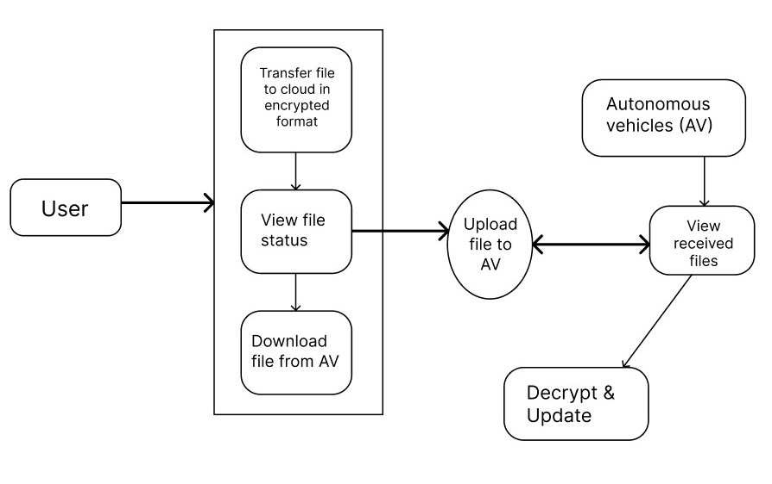
Figure-1: Proposed Architecture

Figure-1 Show’s to the working of architecture for secure file transfer between a user and Autonomous vehicles (AVs).

So the actual steps includes,

- User: initiates the process.

- Transfer: transferring files to cloud in encrypted format.

- File status: check the file status.

- Download: download file form AV.

- Upload: upload file from AV.

- Receive: AV receiving the files.

- Decrypt and update: System decrypt and update as needed

In the context of an autonomous vehicle (AV) system architecture, the process begins with transferring files to the cloud in an encrypted format to ensure data security during transmission and storage. Once files are uploaded, users can view the file status to check for successful transfers or errors. Files can also be downloaded from the AV to local systems for analysis or backup, while uploading allows for the transfer of necessary data, such as updates or maps, back to the AV. Additionally, users can view received files to verify their integrity and correctness. After retrieving files, decryption is performed to make the data readable, followed by updates to the vehicle's system, ensuring it operates efficiently with the latest information and configurations.

- Data Processing:
Removing the URL and other characters: In this step, URLs within the textual data are removed to eliminate irrelevant information and standardize the content. This ensures that any external links, which may not contribute to the core analysis, are excluded from the text. Additionally, special characters, symbols, and non-alphanumeric characters are stripped from the text. This process cleanses the data by removing extraneous elements that can interfere with text processing and analysis. By focusing solely on relevant text, the consistency of the dataset is improved, facilitating more efficient and accurate feature extraction. This cleanup enhances the overall quality of the data, allowing for more effective subsequent analysis and processing. It helps ensure that the text is streamlined and uniformly formatted, which is crucial for developing robust and reliable fake news detection algorithms.
Remove Punctuations: Punctuation marks, including periods, commas, exclamation points, and question marks, are removed from the text to minimize noise and enhance text analysis tasks. Although punctuation is essential for structuring language and conveying meaning, its presence can interfere with processes like sentiment analysis or keyword extraction. By stripping out these punctuation marks, the text becomes cleaner and more uniform, which aids in achieving more accurate and reliable results in subsequent analysis. This preprocessing step helps streamline the data, making it better suited for tasks such as feature extraction and semantic interpretation. With punctuation removed, the focus shifts to the core content of the text, allowing for clearer insights into the underlying meaning and improving the overall effectiveness of fake news detection algorithms. This step is crucial for refining the quality of the data and ensuring more precise analysis outcomes.
Remove Stop Words: Stop words, such as "the," "is," and "and," are removed from the text to minimize noise and emphasize meaningful content. These commonly occurring words typically carry minimal semantic value and appear frequently across documents, offering little distinction between genuine and fake news. By eliminating stop words, the focus shifts to more relevant and informative terms that contribute to the core message of the text. This preprocessing step streamlines the text analysis process, enhancing the efficiency of feature extraction and classification algorithms. It helps to prioritize significant terms and phrases that are crucial for distinguishing between different types of content. As a result, the text becomes cleaner and more focused, improving the accuracy and effectiveness of subsequent analysis and model performance in fake news detection. This approach ensures that the analysis concentrates on the content that truly impacts the classification outcomes.
- Feature Selection:
Feature selection is a critical component in the data processing pipeline for fake news detection. It involves identifying and retaining the most relevant features from the preprocessed data while removing those that are irrelevant or redundant. In the context of textual data, common feature selection techniques include term frequency-inverse document frequency (TF-IDF), which prioritizes words that are highly indicative of the content's uniqueness and discriminative power. This method helps in emphasizing terms that are significant for distinguishing between genuine and fake news articles.

Additionally, methods such as chi-square tests or mutual information gain can be employed to evaluate the importance of individual features. Chi-square assesses the association between features and the target variable, while mutual information measures the dependency between features and the outcome. By applying these techniques, the system can identify the most informative features and improve classification accuracy. Effective feature selection reduces the risk of over-fitting, where the model may otherwise become too complex and perform poorly on unseen data. Overall, careful feature selection enhances the performance of fake news detection algorithms, ensuring more accurate and reliable results.
- Training & Testing
In the training phase, the preprocessed and feature-selected data are used to train machine learning models for fake news detection. This process involves inputting the labeled training dataset into the learning algorithm, which iteratively adjusts its parameters to minimize classification errors and enhance its ability to distinguish between genuine and fake news. During this phase, the model learns patterns and features that are indicative of fake news, optimizing its internal parameters based on the training data. This training process is crucial as it equips the model with the knowledge required to make accurate predictions when encountering new, unseen data.
After training, the model’s performance is evaluated using a testing dataset, which is a separate set of labeled data not utilized during the training phase. By testing on this separate dataset, the system provides an unbiased assessment of the model's ability to generalize its learning to new data. The testing phase is essential for determining how well the model can classify unseen instances of news as genuine or fake. By using distinct datasets for training and testing, the framework ensures that the model is robust and generalizes well to new, unseen examples, reducing the risk of overfitting. Typically, an 80-20 split is used, where 80% of the data is allocated for training and 20% for testing, striking a balance between effective learning and rigorous evaluation. This method helps in validating the system's effectiveness in real-world scenarios, ensuring that the fake news detection framework can reliably identify misinformation.

- Algorithms

CPABE Algorithm
The Cipher text-Policy Attribute-Based Encryption (CPABE) algorithm is a cryptographic scheme that allows for fine- grained access control over encrypted data based on user attributes. In CPABE, each user is associated with a set of attributes, and the data owner defines an access policy specifying which attributes a user must possess to decrypt the data. The encryption process involves creating a cipher text that is tied to the access policy, while users generate their secret keys based on their attributes. When a user attempts to decrypt the cipher text, the algorithm checks if the user's attributes satisfy the policy embedded in the cipher text. If they do, the user can successfully decrypt the data; if not, access is denied. This mechanism provides a secure and flexible way to manage data access in scenarios where multiple users with varying permissions interact with sensitive information.

AES Algorithm
In this Project AES is the algorithm which we used to get reference from the previous existing system, so using of AES Encryption algorithm will get a idea on key sharing encryption between one file to another.
You take the following AES steps of encryption for a
128-bit block:
Derive the set of round keys from the cipher key.
Initialize the state array with the block data
(plaintext).
Add the initial round key to the starting state array.
Perform nine rounds of state manipulation.
Perform the tenth and final round of state
manipulation.
Copy the final state array out as the encrypted data
(ciphertext).
- EXPERIMENTAL RESULTS
Dataset
The recommended system's dataset will include an arrangement of user registration of the autonomous vehicles. Alongside data on number of logins attempts and number of registrations done. This assortment includes logins per day, registers per day and also graphical representations of the mean attempts.

Output of the Proposed system:
Figure 2 shows the actual home page for the new user to get registration.
The Actual webpage output for the new user shows in Figure 2 who wants to get register by providing user-credentials like email, password, username, contact number and Address.
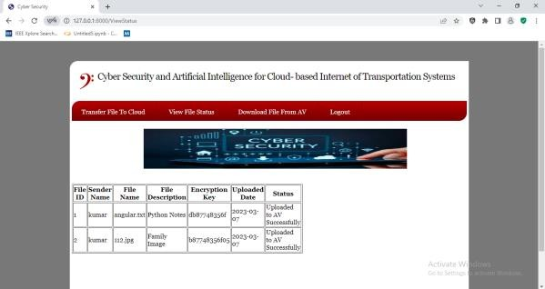
Figure 3 shows the files which are uploaded from the user.
In the figure 3 it shows the interface after uploading the files by the user, then it will be stored to cloud through the open source of cloud platform “Open Cloud” where the section shows Uploaded to AV Successfully.

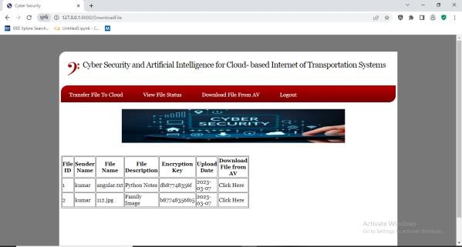
Figure 4 shows the downloadable files which are encrypted by the CPABE and AES algorithms.
The CPABE encrypted files having the encryption key which are uploaded to the cloud using this platform in figure 4 will be available for download.

II Phase of input and output:
Figure 5 show the AV login for the registered user.
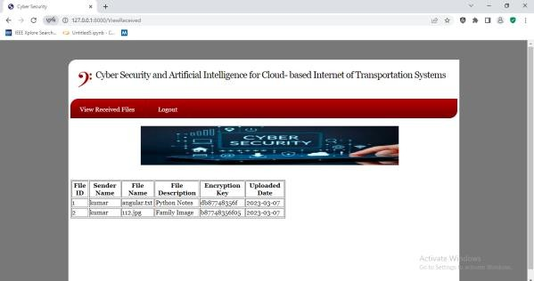
The AV user has to provide the username and password in order to view the received files in Figure 5.
Figure 6 shows the final output of the received files.

Figure 6 shows the results after applying the proposed system methodology. The decrypted file along with the encrypted key will be shown in the result.
Performance Evaluation:
Table 1 – Performance Evaluation Table

Encryption Algorithms | Accuracy | Recall | Precision
CPABE | 0.98 | 0.98 | 0.98
AES | 0.96 | 0.98 | 0.97
Asymmetric Encryption | 0.98 | 1.0 | 0.99

A Comparative performance analysis of the CPABE, AES and Asymmetric Encryption algorithms is presented in Table [1], with and emphasis on the accuracy, precision, recall, and F1 score that each algorithm achieved.

The results of the proposed system were obtained from feature and data analysis carried out on the chosen dataset. The model's performance was evaluated using key metrics that were derived from the confusion matrix, including recall, accuracy, precision, and F1 score.

Accuracy: Accuracy can be expressed as the ratio of correctly predicted cases, including true positives and true negatives, to all instances in the dataset.
Accuracy = $\frac{(TP+TN)}{(TP+FP+TN+FN)}$
Recall:

The ratio of true positives, or positively predicted cases, to all predicted positives, or true and false positives, is known as precision, sometimes known as the positive predictive value.
Recall = $\frac{TP}{(TP+FN)}$
Precision:

The F1-score is the harmonic mean of precision and recall. It offers a balance between the two, particularly in situations when you must give equal weight to false positives and false negatives.
Precision = $\frac{TP}{(TP+FP)}$

Table 2 – Comparison between Existing system and Proposed system.

References | Accuracy | Features
MD5 | 78.00% | Effectively faster but have less secure.
AES | 85.00% | Provides more security for transferring files.
Proposed System | 91.00% | Security and speed is more on transferring files into cloud

- CONCLUSION
In conclusion, Intelligence for Cloud-based Internet of Transportation Systems" successfully bridges the realms of cutting-edge technology and security in modern transportation networks. By synergizing AI-driven anomaly detection and robust cyber security measures, the project contributes to safeguarding cloud-based transportation systems against emerging threats. Continuous monitoring, adaptation, and collaboration are vital components in this evolving landscape. Safeguarding transportation networks through comprehensive cyber security measures not only protects sensitive information but also contributes to the sustained efficiency and safety of advancement and interconnected systems

REFERENCES

- L. Figueiredo, I. Jesus, J. A. T. Machado, J. R. Ferreira, and J. L. M. de Carvalho, “Towards the development of intelligent transportation systems,” in ITSC 2001 IEEE Intelligent Transportation Systems., Aug 2001, pp. 1206–1211.
- R. Quinonez, J. Giraldo, L. Salazar, E. Bauman, A. Cardenas, Z. Lin, Securing Autonomous Vehicles with a Robust Physics-Based Anamoly Detector. 29th USENIX Security Symposium (USENIX Security 20). Boston, MA, August 2020.
- B. M. Thuraisingham, Sec AI: Integrating Cyber Security and Artificial Intelligence with Applications in Internet of Transportation and Infrastructures, Clemson University Center for Connected Multimodal Mobility, Annual Conference, October 2019.
- Y. Zhou, M. Kantarcioglu, B. M. Thuraisingham, B. Xi, Adversarial support vector machine learning. ACM KDD 2012: 1059-1067
- B. M. Thuraisingham, P Pallabi, M. Masud, L. Khan, Big Data Analytics with Applications in Insider Threat Detection, CRC Press, 2017.
- M. Masood, L. Khan, and B. Thuraisingham, Data Mining Applications in Malware Detection, CRC Press 2011
- K. W. Hamlen, V. Mohan, M. M. Masud, L. Khan, B. M. Thuraisingham: Exploiting an antivirus interface. Comput. Stand. Interfaces 31(6): 1182- 1189 (2009)
- L. Liu, M. Kantarcioglu, B. M. Thuraisingham: The applicability of the perturbation based privacy preserving data mining for real-world data. Data Knowl. Eng. 65(1): 5-21 (2008)
- G. Ayoade, V. Karande, L. Khan, K. W. Hamlen, Decentralized IoT Data Management Using BlockChain and Trusted Execution Environment. IRI, pp 15-22, 2018
- B. M. Thuraisingham, M. Kantarcioglu, E. Bertino, J. Z. Bakdash, M. Fernández, Towards a Privacy-Aware Quantified Self Data Management Framework. SACMAT, pp 173-184, 2018
- G. Ayoade, V. Karande, L. Khan, K. W. Hamlen, Decentralized IoT Data Management Using BlockChain and Trusted Execution Environment. IRI, pp 15-22, 2018
- K. W. Hamlen, M. Kantarcioglu, L. Khan, B. M. Thuraisingham, Security Issues for Cloud Computing. IJISP 4(2): 36-48 (2010)
- G. Ayoade, V. Karande, L. Khan, K. W. Hamlen, Decentralized IoT Data Management Using BlockChain and Trusted Execution Environment. IRI, pp 15-22, 2018
- 12] G. Ayoade, V. Karande, L. Khan, K. W. Hamlen, Decentralized IoT Data Management Using BlockChain and Trusted Execution Environment. IRI, pp 15-22, 2018
- S. de Luca, R. D. Pace, A. D. Febbraro, and N. Sacco, “Transportation Systems With Connected and Non-Connected Vehicles: Optimal Traffic Control,” in 2017 5th IEEE International Conference on Models and Technologies for Intelligent Transportation Systems (MT-ITS). Naples, Italy: IEEE, June 2017, pp. 13–18.
- H. Qin and C. Yu, “A Road Network Connectivity Aware Routing Protocol for Vehicular Ad Hoc Networks,” in 2017 IEEE International Conference on Vehicular Electronics and Safety (ICVES). Vienna, Austria: IEEE, June 2017, pp. 57– 62.
- M. Alam, J. Ferreira, and J. Fonseca, “Introduction to Intelligent Transportation Systems,” in Intelligent Transportation Systems. Springer, 2016, pp. 1–17.
- A. Munir, “Safety Assessment and Design of Dependable Cybercars: For today and the future,” IEEE Consumer Electronics Magazine, vol. 6, no. 2, pp. 69–77, April 2017.
- K. B. Kelarestaghi, K. Heaslip, and R. Gerdes, “Vehicle Security: Risk Assessment in Transportation,” arXiv preprint arXiv:1804.07381, 2018.
- J. B. Kenney, “Dedicated Short-Range Communications (DSRC) Standards in the United States,” Proceedings of the IEEE, vol. 99, no. 7, pp. 1162–1182, July 2011.
- K. M. Bayarou, “E-Safety Vehicle Intrusion Protected Applications,” 2008. [Online]. Available: https://www. evita-project.org/index.html
- T. Wollinger, “OVERSEE - Open Vehicular Secure Platform,” 2010. [Online]. Available: https://www.oversee-project.com/ index.html
- J. M. d. Fuentes, A. I. Gonz ´alez-Tablas, and A. Ribagorda, “Overview of Security Issues in Vehicular Ad-Hoc Networks,” 2010.
- L. He and W. T. Zhu, “Mitigating DoS Attacks Against SignatureBased Authentication in VANETs,” in 2012 IEEE International Conference on Computer Science and Automation Engineering (CSAE). Zhangjiajie, China: IEEE, May 2012, pp. 261–265.
- B. Poudel and A. Munir, “Design and Evaluation of a Reconfigurable ECU Architecture for Secure and Dependable Automotive CPS,” IEEE Transactions on Dependable and Secure Computing, 2018.
- Satish, Karuturi S R V, and M Swamy Das. "Quantum Leap in Cluster Efficiency by Analyzing Cost-Benefits in Cloud Computing." In Computer Science and Engineering by Auroras Scientific Technological & Research Academy Hyderabad, vol. 17, no. 2, pp. 58-71. Accessed 2018.

